**ASSIGNMENT REPORT**

Data preprocessing and Feature engineering:

* Exploratory data analysis was performed on the provided dataset.
* All the categorical variables were converted into dummy variables
* Features such as subscription period, age groups and Total bill were extracted.

Model selection:

* The feedforward neural network model comprises three layers: input(10 neurons , shape determined by training data, x_train), hidden(5 neurons), and output(1 neuron). It's trained using stochastic gradient descent with binary cross-entropy loss over 5 epochs and a batch size of 32.
* The predictions made by the neural network were concatenated horizontally with the original features from the test dataset (x_test).
* This combined dataset was used as input for the subsequent XGBoost classifier.(xgb_model) with 1000 estimators.
* The trained XGBoost model to make predictions on the same dataset, resulted in (xgb_predictions).

Model Metrics:

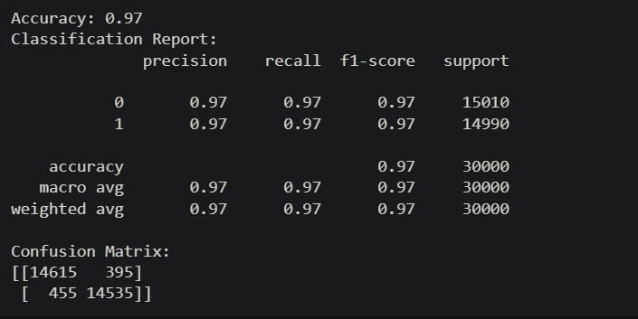

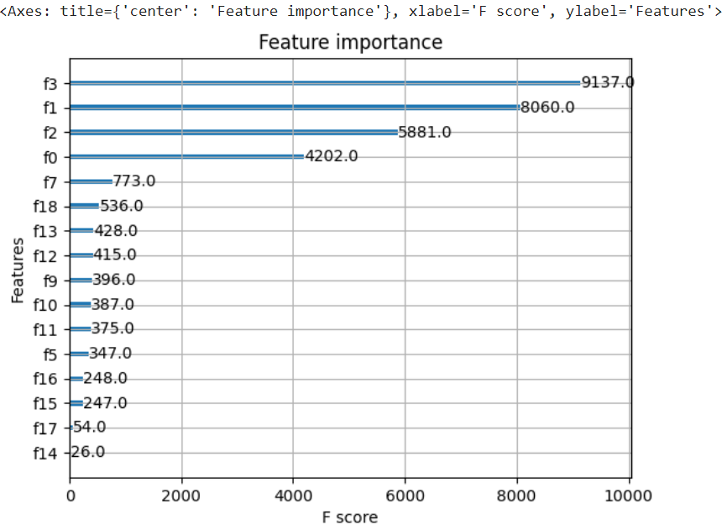

Deployment:

* The model was deployed using flask with a simple UI

